IAM S3

AWS Task 1
Tamar Tutisani

Contents
Executive Summary 3
1 AWS Account Access and Configuration 3
1.1 Console Login and Role Switching 3
1.2 AWS CLI Configuration via SSO 3
1.3 IAM Role Assumption for Programmatic Access 4
2 Data Export from PostgreSQL to CSV 5
2.1 Exporting BL_DM Schema Tables 5
3 S3 Bucket Creation and Data Upload 5
3.1 Creating the S3 Bucket 5
3.2 Creating the Folder Hierarchy 6
3.3 Uploading to S3 6
4 AWS Glue Crawler Configuration and Table Discovery 7
4.1 Setting Up the Glue Crawler 7
4.2 Running and Verifying the Crawler 9
4.3 Verifying Table Discovery 10
5 Querying Data with Amazon Athena 10
5.1 Athena Setup 10
5.2 Running a Non-Trivial Query 11
5.3 Query Results 12
Summary and Findings 13

Executive Summary
This lab demonstrates the setup and integration of AWS cloud services for data warehouse migration. Specifically, I established secure access to AWS using IAM roles, exported dimensional tables from a PostgreSQL database, uploaded them to Amazon S3, cataloged them using AWS Glue, and queried them using Amazon Athena. The work involved five main phases: AWS account access, data export and upload, crawler configuration, table discovery, and query execution.

AWS Account Access and Configuration

Console Login and Role Switching
To begin, I accessed the AWS account using the link provided in the EPAM notification email. After selecting "User" and logging into the AWS Management Console, I switched to the students-role with the necessary permissions. This role grants the required access to S3, Glue, and Athena services while maintaining proper security boundaries.
I verified that the region was set to Frankfurt (eu-central-1), as specified in the task requirements(Figure 1). All subsequent AWS operations were performed in this region to ensure data residency.
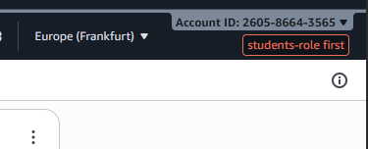
Figure 1. Students role and region set

AWS CLI Configuration via SSO
To enable command-line access to AWS services, I installed AWS CLI v2 on my Windows machine and configured it using the AWS SSO authentication method. I ran the command:
aws configure sso

I provided the following SSO details:
SSO session name: user-role
SSO start URL: https://epam.awsapps.com/start#
SSO region: us-east-1
CLI region: eu-central-1
Profile name: user-role-260586643565

(Figure 2 shows the SSO configuration interface)

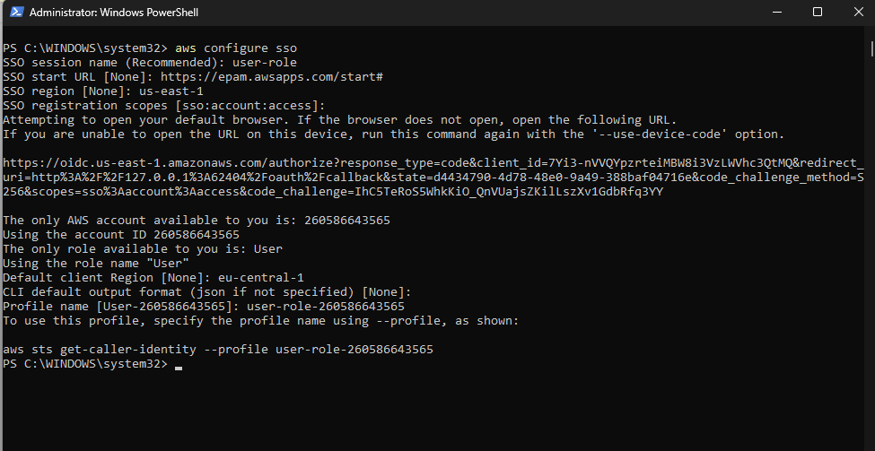
Figure 2. AWS SSO configuration

IAM Role Assumption for Programmatic Access
Since the User role alone does not have sufficient permissions, I manually edited the AWS config file (C:\Users\<username>\.aws\config) to add a new profile that assumes the students-role:
[profile students-role]
role_arn = arn:aws:iam::260586643565:role/students-role
source_profile = user-role-260586643565
region = eu-central-1

This configuration allows the CLI to use the User profile as a source and then assume the students-role for actual API calls. I verified the setup by running:
aws sts get-caller-identity --profile students-role

The response confirmed successful role assumption and showed my account ID (260586643565) and the assumed role ARN (Figure 3).
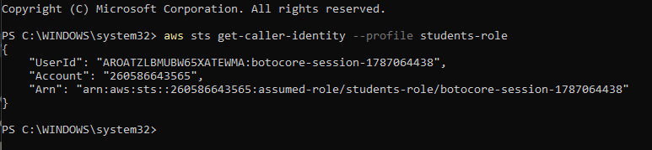
Figure 3. AWS STS Verification

Data Export from PostgreSQL to CSV

Exporting BL_DM Schema Tables
My PostgreSQL database contains a dimensional model in the bl_dm schema with seven key tables:
- Dimension tables: dim_time_day, dim_products, dim_customers_scd, dim_geography, dim_employees, dim_order_attributes
- Fact table: fct_sales_dd
To export these tables for cloud storage, I created a PowerShell script that connects to the local PostgreSQL instance and exports each table as a CSV file with headers and proper encoding. The script performs the following:
- Sets environment variables for PostgreSQL connection (host, username, password, database)
- Iterates through each table name
- For dimension tables, uses the \copy command to export with CSV format and headers
- For the fact table (fct_sales_dd), uses a SELECT query and programmatically adds headers using the information schema
- Saves each file to C:\aws_export\<table_name>.csv
The export completed successfully with all 7 tables exported to CSV format (Figure 4 shows the successful export output with file sizes for each table).
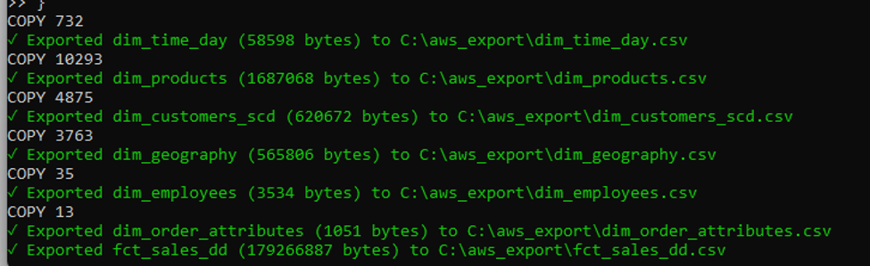
Figure 4. Successful Export of Database Tables to CSV

S3 Bucket Creation and Data Upload

Creating the S3 Bucket
Using the AWS CLI with the students-role profile, I created a new S3 bucket with a recognizable naming convention:
aws s3 mb s3://tamar-tutisani-epam-lab --region eu-central-1 --profile students-role
I then applied the mandatory owner tag to the bucket:
aws s3api put-bucket-tagging --bucket tamar-tutisani-epam-lab --tagging "TagSet=[{Key=owner,Value=student}]" --profile students-role
(Figure 5 shows the S3 bucket creation and tagging process)
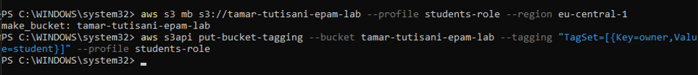
Figure 5. S3 Bucket Creation and Tagging

Creating the Folder Hierarchy
Following AWS best practices for data warehouse organization, I created a hierarchical folder structure locally that mirrors the intended S3 structure(Figure 6)
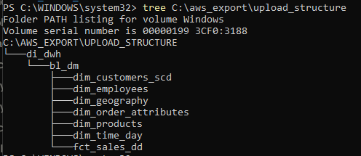
Figure 6. Upload Folder Structure
Each table's CSV file was placed in its respective subfolder. This structure allows the Glue crawler to recognize and organize tables by their logical grouping in the data warehouse.

Uploading to S3
I uploaded the entire folder structure to S3 using the recursive copy command:
aws s3 cp C:\aws_export\upload_structure\di_dwh\ s3://tamar-tutisani-epam-lab/di_dwh/ --recursive --profile students-role
This command uploaded all CSV files while preserving the folder structure. Figure 7 shows the successful upload, with each table file copied to its corresponding S3 path (e.g., s3://tamar-tutisani-epam-lab/di_dwh/bl_dm/dim_products/dim_products.csv).
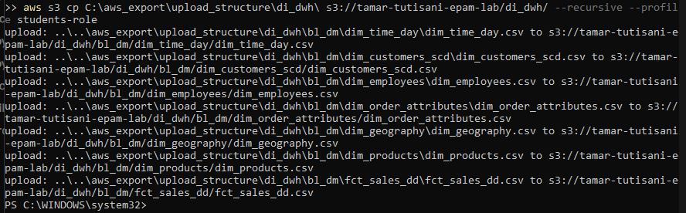
Figure 7. S3 Recursive Upload of Data Warehouse CSV Files

AWS Glue Crawler Configuration and Table Discovery

Setting Up the Glue Crawler
AWS Glue Crawlers automatically detect the schema of data stored in S3 and populate the Glue Data Catalog with table metadata. I configured the crawler as follows:
Step 1: Create Crawler
- Opened the AWS Glue console and navigated to Crawlers
- Clicked "Create crawler" and entered the name bl_dm_crawler (using underscores per AWS naming best practices)
- Applied tag: Key: owner, Value: student
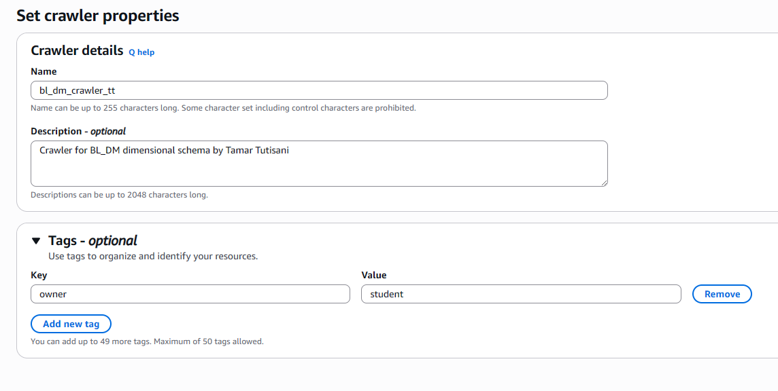
Figure 8. Step 1: Configuring AWS Glue Crawler Name, Description, and Tags
Step 2: Specify Data Source
- Selected S3 as the data source
- Provided the S3 path: s3://tamar-tutisani-epam-lab/di_dwh/bl_dm/
- Enabled "Crawl all sub-folders" to ensure all table folders are discovered
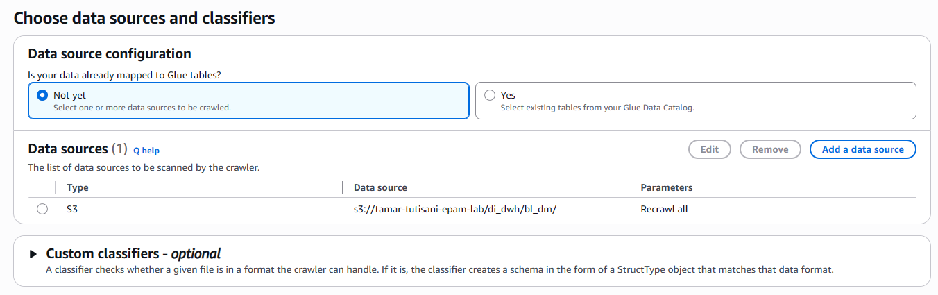
Figure 9. Step 2: Selecting Data Source Configuration and S3 Path
Step 3: Assign IAM Role
- Selected an appropriate IAM role with S3 read and Glue service permissions (dilab-glue-role)
- The role's trust policy allows the Glue service to assume it
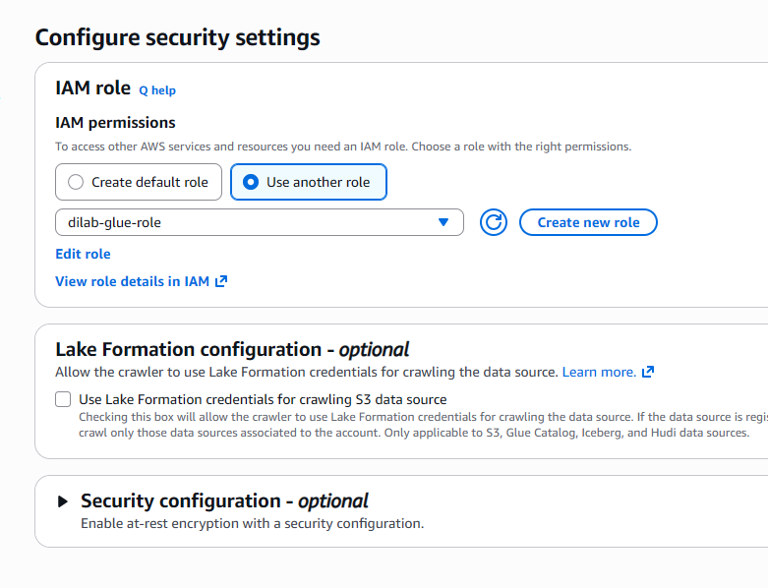
Figure 10. Step 3: Configuring Security Settings and Assigning the IAM Role (dilab-glue-role)
Step 4: Configure Output Database
- Created a new Glue Data Catalog database named bl_dm_catalog
- This database stores metadata for all discovered tables
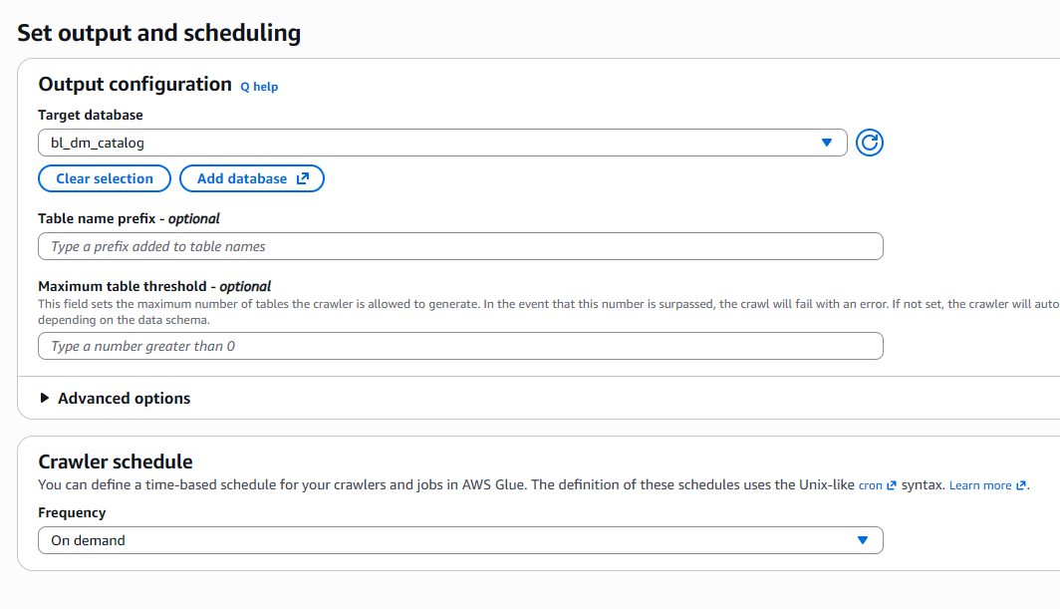
Figure 11. Step 4: Setting Target Database (bl_dm_catalog) and On-Demand Schedule
Step 5: Review and Create
- Reviewed all settings and clicked "Create crawler"
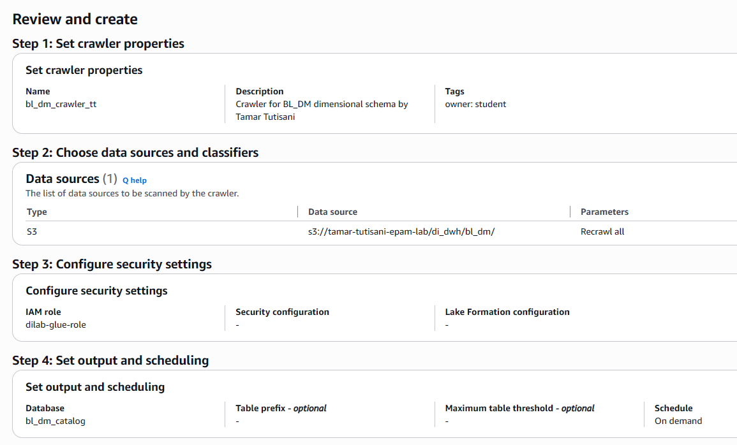

Figure 12. Final Review and Summary of All Crawler Configuration Steps

Running and Verifying the Crawler
I clicked "Run crawler" and monitored its execution. The crawler transitioned through states (STARTING > RUNNING > READY) and completed in approximately 2 minutes. The execution summary reported "Tables added: 7," confirming that all seven tables were successfully discovered and cataloged (Figure 13).
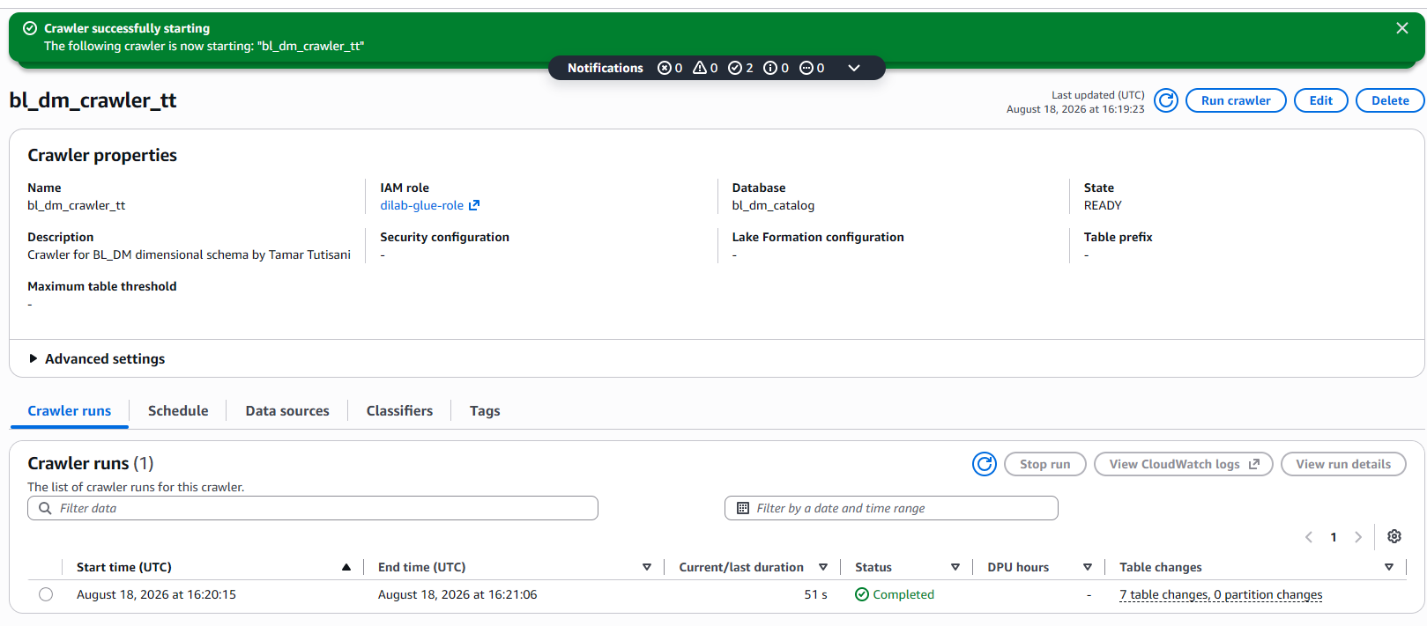
Figure 13. Successful Execution and Run Status of the Glue Crawler

Verifying Table Discovery
I navigated to the Glue Data Catalog's Tables section and verified that all 7 tables appeared in the bl_dm_catalog database:
- dim_time_day
- dim_products
- dim_customers_scd
- dim_geography
- dim_employees
- dim_order_attributes
- fct_sales_dd
Clicking on individual tables displayed their inferred schema, including column names, data types, location in S3, and record counts. Figures 14 shows the discovered tables in the Data Catalog and the detailed schema information.
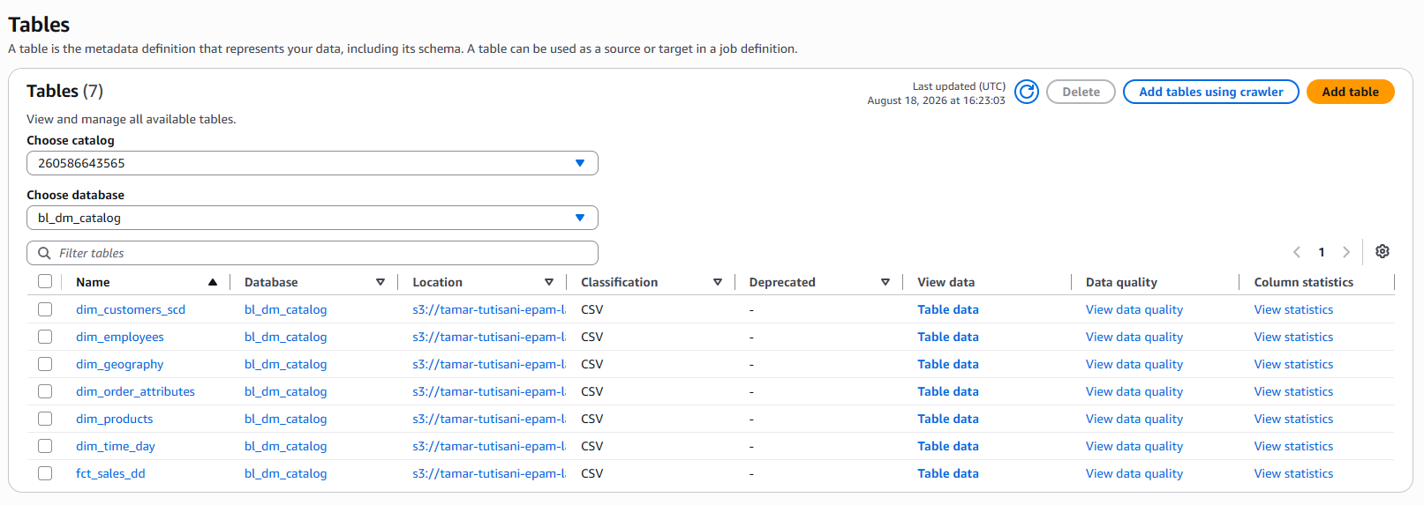
Figure 14. Discovered Tables in the Glue Data Catalog (bl_dm_catalog)

Querying Data with Amazon Athena

Athena Setup
Amazon Athena allows SQL queries directly against data in S3 using the Glue Data Catalog as the metadata source. I opened the Athena console and verified the Frankfurt region was selected.
In the left sidebar under the Data section, I set:
- Data source: AwsDataCatalog
- Database: bl_dm_catalog
All 7 tables from my Glue catalog appeared in the table list on the left sidebar (Figure 15).
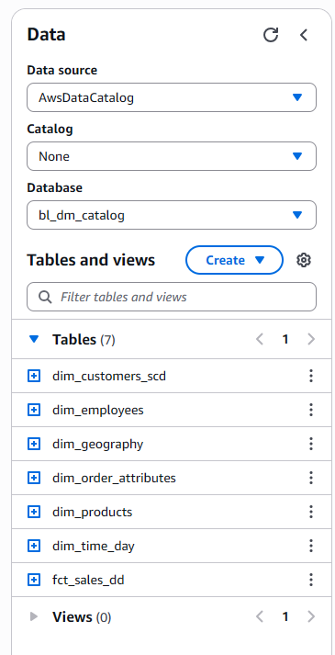
Figure 15. Data Sidebar Showing the Database and Tables (bl_dm_catalog)

Running a Non-Trivial Query
Rather than executing a simple SELECT *, I ran a more complex analytical query that demonstrates joins, aggregations, and filtering:
SELECT
p.product_name,
COUNT(f.order_id) as total_orders,
SUM(f.sales_amt) as total_sales,
AVG(f.profit_amt) as avg_profit
FROM bl_dm_catalog.fct_sales_dd f
LEFT JOIN bl_dm_catalog.dim_products p
ON f.product_surr_id = p.product_surr_id
WHERE p.product_name IS NOT NULL
GROUP BY p.product_name
ORDER BY total_sales DESC
LIMIT 50000;
This query:
- Joins the fact table (fct_sales_dd) with the product dimension (dim_products)
- Filters for non-null product names
- Aggregates data by product, calculating total orders, total sales, and average profit
- Orders results by total sales in descending order
- Limits results to 50,000 rows as per task requirements
(Figure 16 shows the query editor with this SQL)
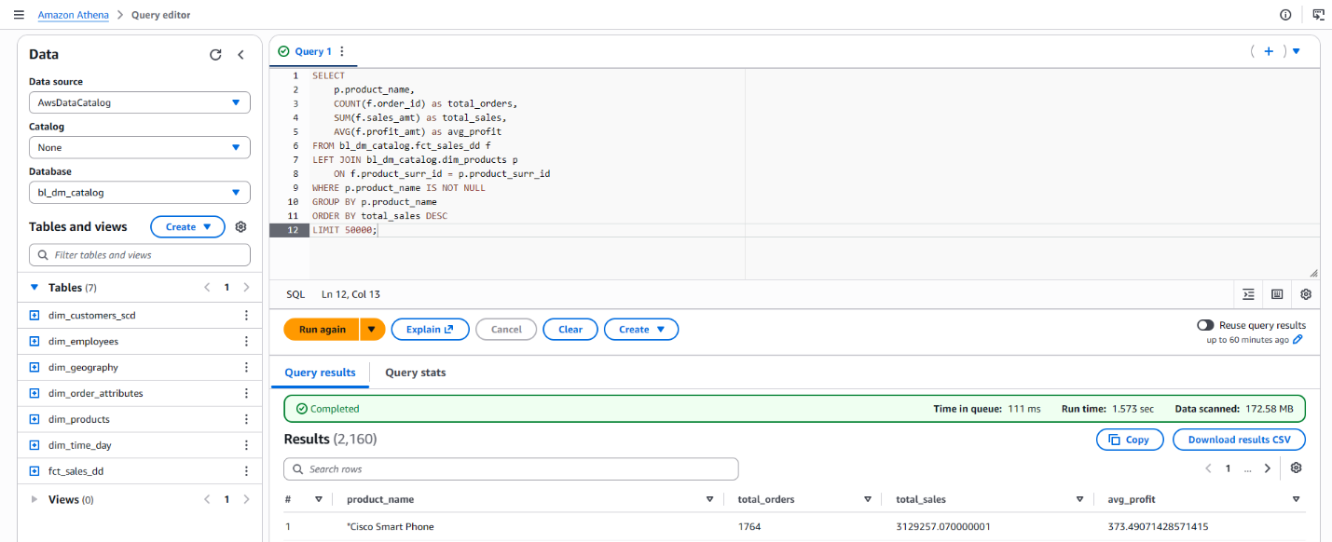
Figure 16. Amazon Athena Query Editor and Product Sales Analysis Query

Query Results
The query executed successfully in a few seconds and returned results showing product performance metrics. Each row represents a product with its associated order count, total sales amount, and average profit (Figure 17 shows the query results table).
The results demonstrate that the data pipeline is working correctly: data from PostgreSQL was successfully exported, uploaded to S3, cataloged by Glue, and is now queryable via Athena's SQL interface.
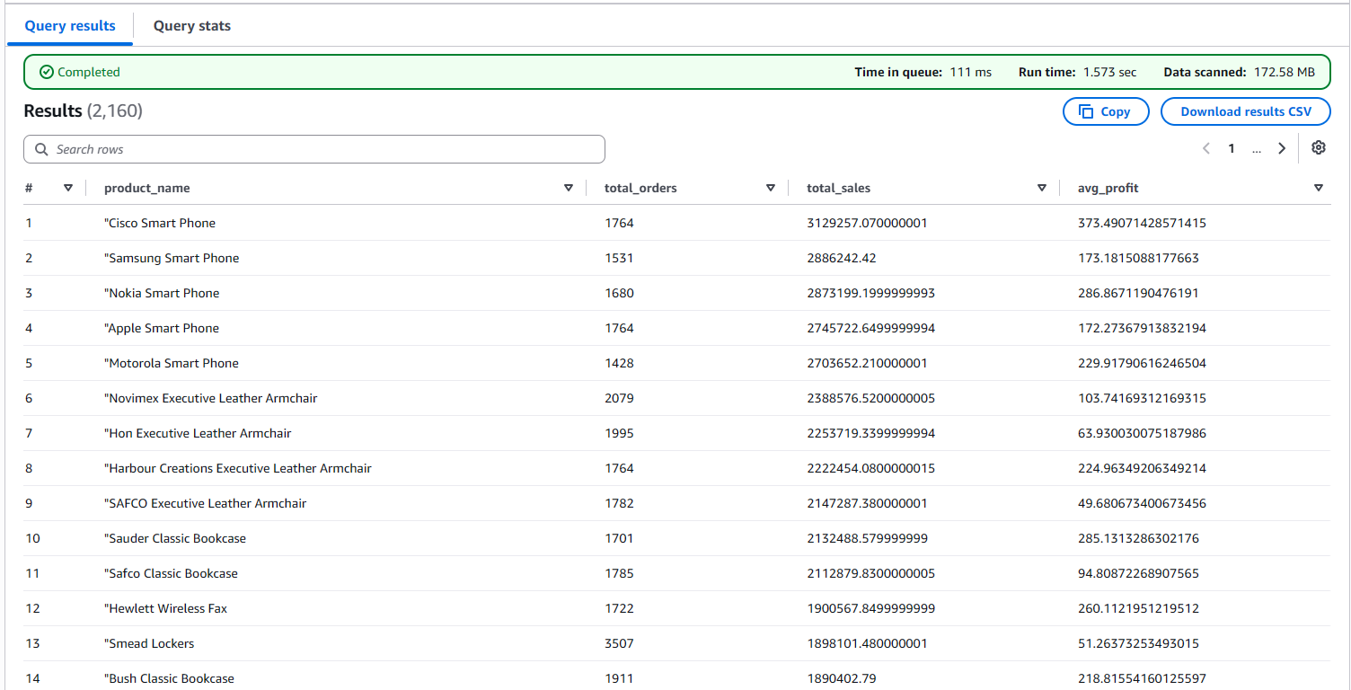
Figure 17. Query Results

Summary and Findings
This lab successfully demonstrates the integration of multiple AWS cloud services for a data warehouse use case:
- Identity and Access Management (IAM): Configured secure, role-based access using AWS SSO and role assumption
- Amazon S3: Created a properly tagged bucket and organized data with hierarchical folder structure
- AWS Glue: Automated table discovery and metadata cataloging from raw CSV files
- Amazon Athena: Enabled SQL-based querying of cloud-resident data without provisioning compute resources
All AWS resources created during this lab were tagged with:
- Key: owner
- Value: student
The dimensional model tables from PostgreSQL are now accessible in the cloud, supporting analytical queries on products, customers, geography, employees, and sales facts. The architecture follows AWS best practices for data organization, access control, and cost optimization.

